**Introduction of Real-Wheel Drive Steering Car Chassis**

**Table**

1. Preface 1

2. Real-Wheel Drive Steering Car Chassis Structure 2

3. Control Board 4

4. Safety and Notes 6

5. Make your suggestion and get support 6

# Preface

Thank you for purchasing and using this Real-Wheel Drive Steering Car Chassis kit from COKOINO.

Our aim is to provide you with a Real-Wheel Drive Steering Car Chassis frame with cool appearance, strong expandability and diverse gameplay.

It uses large wheels with an outer diameter of 65mm and black hubs. The front wheels are assembled on the steering shaft, with a maximum left and right steering angle of 45 degrees. The steering shaft is driven by one MG90S servo motor, and the rear wheels are mounted on the TT motor shaft,2 TT Motors are used as its drive motors. The multifunctional acrylic car body plate can support the assembly of different types of control boards, such as Arduino UNO board and Raspberry Pi 4B, so you can choose the control board you favorite to assemble on this Steering car, and the acrylic support plate also reserves a place for you to assemble the servo, you can assemble the servo and DIY the head of the car body, such as the ultrasonic module and bracket can be extended to the servo to make the car body more functional and interesting. The front and rear of the car body are equipped with a multi-functional extended acrylic. You can use the above slots and holes to DIY various sensor modules, making the experiment more rich and interesting.

# Real-Wheel Drive Steering Car Chassis Structure

2.1 Assemble and install

Please refer to the documentation: Real-Wheel Drive Steering Car Chassis Kit Tutorial\3 How to Assemble the Real-Wheel Drive Steering Car Chassis for Arduino

2.2 Structural composition

This Real-Wheel Drive Steering Car Chassis is mainly composed of the following parts：TT Motor，acrylic Chassis frame， acrylic support plate , acrylic expansion plate,18650 battery box

**Top View**

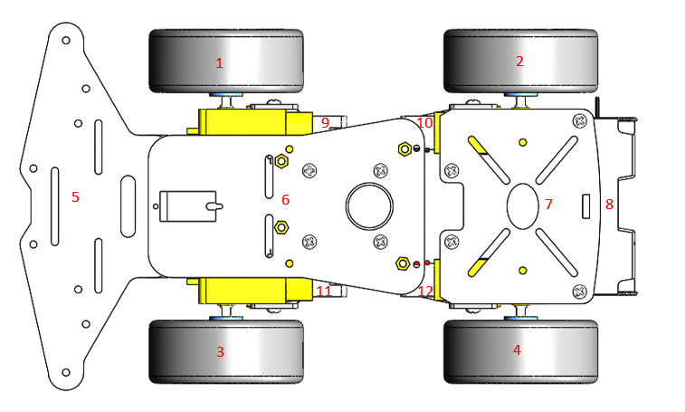

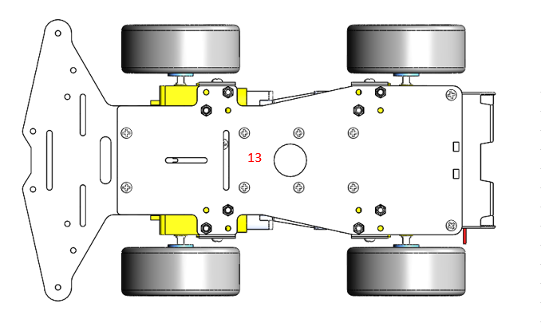**Bottom View**

|  |  |
| --- | --- |
| **Part No.** | **Module** |
| 1,2,3,4 | wheel |
| 5 | acrylic expansion plate |
| 6 | acrylic support plate |
| 7 | acrylic expansion plate |
| 8 | 18650 battery box |
| 9,10,11,12 | TT Motor |
| 13 | acrylic chassis frame |

Details of the modules listed above

[1,2,3,4]: Wheel. 4pcs wheel of the Steering car - outer diameter 65mm, inner diameter 45mm, blue hub

[5]: Acrylic expansion plate - Acrylic expansion board at the front of the car body, you can expand some sensor modules and actuators through the holes above

[6]: Acrylic car body plate. The support platform for the control board, you can fix your control board with copper pillars and screws.

[7]: Acrylic expansion plate - Acrylic expansion board at the rear of the frame, which can fix the sensor module, 1602LCD screen, etc. through the holes above

[8]: 18650 battery box - You can mount two 18650 batteries on it to power the robot.

[9,10,11,12]: TT Motor. 4PCS TT Motor - controlled by the control board to drive 4 wheels

[13]: acrylic chassis frame - An important part of a Steering car, it is the carrier board for all other modules

# Control Board

The multifunctional acrylic car body plate can support the assembly of different types of control boards.

**Support Arduino**:UNO R3/UNO R4/Leonardo

**Support Raspberry Pi:** Raspberry Pi 5/4B/3B+/3B/ 2B/ 1B+

Demo1: Select the Arduino UNO R3 board and install it on the acrylic support plate of the car body, as follows

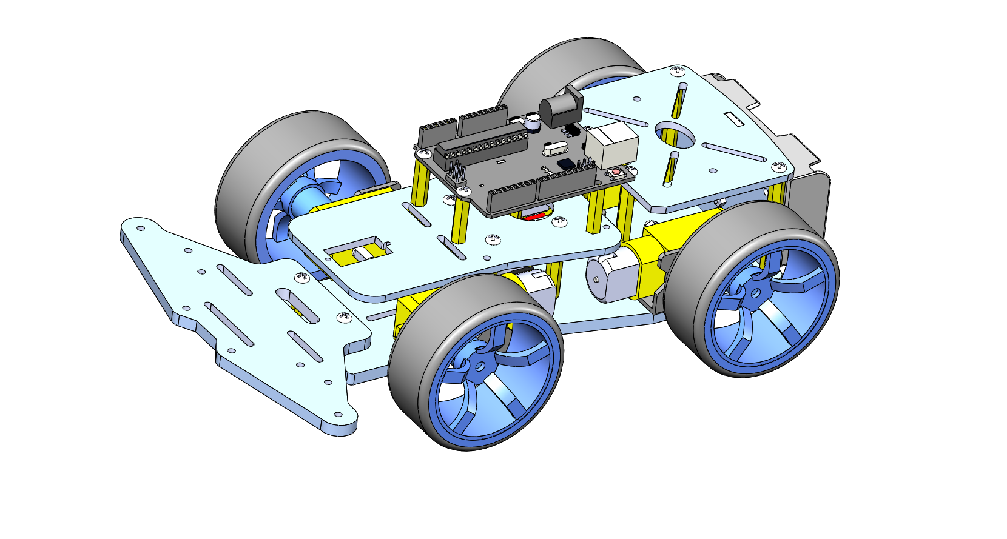

Demo2: Select the Raspberry Pi 4B board and install it on the acrylic support plate of the car body, as follows

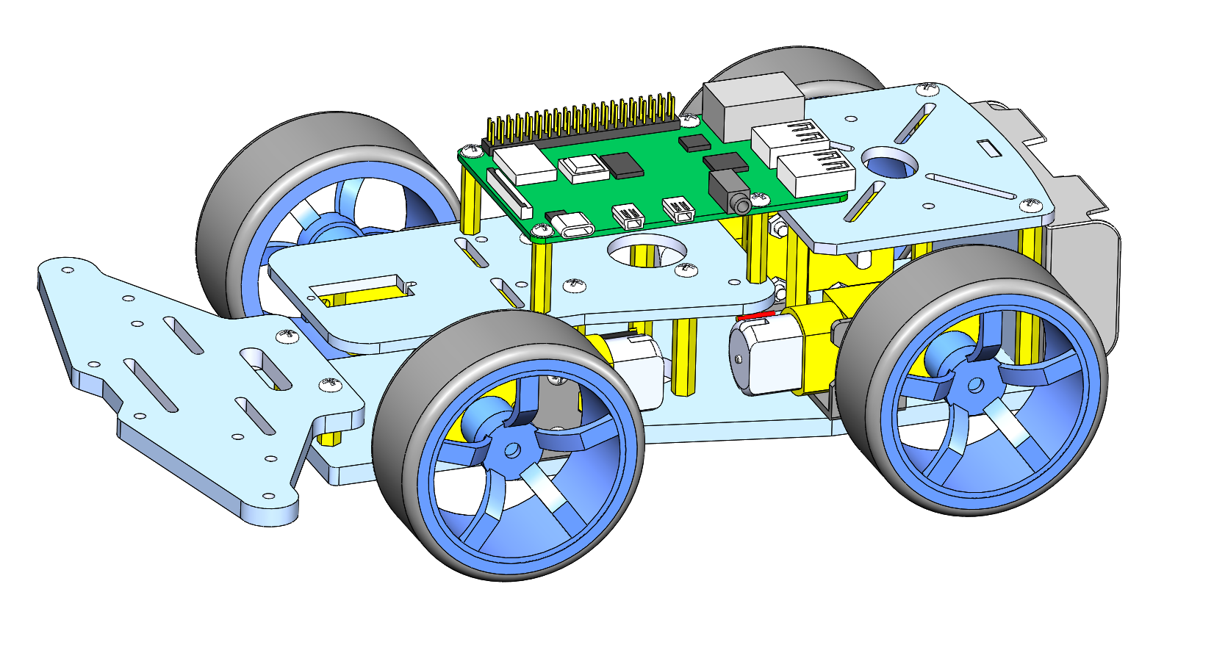

# Safety and Notes

4.1 Please refer to the document CKK0020-main\ Tutorial\Arduino\3 How to Assemble the Real-Wheel Drive Steering Car Chassis. Pay attention to the specifications of the screws to prevent using them in the wrong place.

4.2 Before powering on, please make sure that all connected circuits are not short-circuited, especially 3.3V and GND

A short circuit can cause high current in your circuit, create excessive component heat and cause permanent damage to your hardware!

4.3 This kit is designed to provide a set of car bodies that can be defined by yourself and can be played in multiple ways. The development boards, sensor modules, brackets, etc. needed for DIY need to be prepared by you.

# Make your suggestion and get support

THANK YOU for reading this introduction of the Real-Wheel Drive Steering Car Chassis !

If you find errors,omissions or you have suggestions and/or questions about this document, please feel free to contact us: **[cokoino@outlook.com](mailto:cokoino@outlook.com)**

We will make every effort to make changes and correct errors as soon as feasibly possible and publish a revised version.

If you want to learn more about Arduino, Raspberry Pi, Smart Cars, Robotics and other interesting products in science and technology, please continue to visit our Amazon Store by search for "LK COKOINO" on Amazon. We will continue to launch fun, cost-effective, innovative and exciting products.

Thank you again for choosing Cokoino products.

**LK COKOINO**